OS LAB INTERRUPTS

Question 1:
Code:
#include<stdio.h>
#include<signal.h>
#include<unistd.h>

void sig_handler(int signo)
{
if (signo == SIGINT)
printf("received SIGINT\n");
}

int main(void)
{
if (signal(SIGINT, sig_handler) == SIG_ERR)
printf("\ncan't catch SIGINT\n");
// A long long wait so that we can easily issue a signal to this process
while(1)
sleep(1);
return 0;
}

Output:

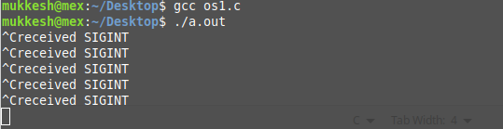

Question 2:
Code:

#include<stdio.h>
#include<signal.h>
#include<unistd.h>

void sig_handler(int signo)
{
if (signo == SIGUSR1)
printf("received SIGUSR1\n");
else if (signo == SIGKILL)
printf("received SIGKILL\n");
else if (signo == SIGSTOP)
printf("received SIGSTOP\n");
}

int main(void)
{
if (signal(SIGUSR1, sig_handler) == SIG_ERR)
printf("\ncan't catch SIGUSR1\n");
if (signal(SIGKILL, sig_handler) == SIG_ERR)
printf("\ncan't catch SIGKILL\n");
if (signal(SIGSTOP, sig_handler) == SIG_ERR)
printf("\ncan't catch SIGSTOP\n");
// A long long wait so that we can easily issue a signal to this process
while(1)
sleep(1);
return 0;
}

Output:

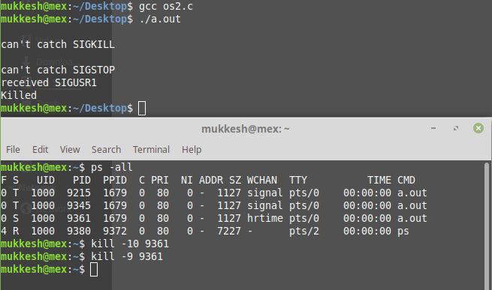
Question 3:
Code:
#include <stdio.h>
#include <sys/types.h>
#include <signal.h>
#include <unistd.h>

static int received = 0;

void readUsual(int sig)
{
if (sig == SIGUSR1)
{
received = 1;
}
}

int main()
{
signal(SIGUSR1,readUsual);

pid_t pid2 = fork();
if (pid2 < 0)
printf("Can't create child process\n");
else if (pid2==0)
{
printf("Process2, pid=%d\n",getpid());
while (!received)
;
printf("SIGUSR1 received.\n");
}
else
{
kill(pid2,SIGUSR1);
printf("%s\n","Proccess1 end");
while (1) ;
}

return 0;
}

Output:
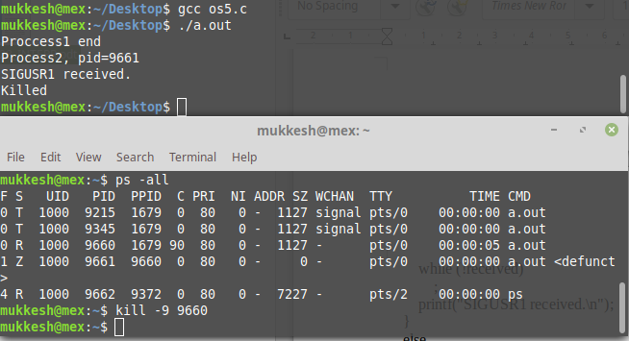
Question 4:
Code:

#include <stdio.h>
#include <sys/types.h>
#include <signal.h>
#include <unistd.h>
#include<stdlib.h>

int sleepo = 0;
int wakeo = 0;

void readUsual(int sig)
{
if (sig == SIGUSR1)
{
sleepo = 1;
wakeo=0;
}
if (sig == SIGUSR2)
{
sleepo=0;
wakeo=1;
}
}

int main()
{
signal(SIGUSR1,readUsual);
signal(SIGUSR2,readUsual);
int b;
pid_t x,pid2 = fork();
if (pid2 < 0)
printf("Can't create child process\n");
else if(pid2==0)
{
printf("I am Child. I am sending to parent\n");
x=getppid();
printf("Select your option \n \n1) Sleep parent. 2) Wake up parent \n");
scanf("%d", &b);
if(b==1)
kill(x,SIGUSR1);
else if(b==2)
kill(x,SIGUSR2);
else
printf("Error");
while (1);
}
else if (pid2!=0)
{
printf("I am Parent, pid=%d\n",getpid());
while(1)
{
while (!wakeo && !sleepo);
if(sleepo==1)
{
printf("Parent is going to sleep\n");
while(1)
sleep(1);
}
else if(wakeo==1)
break;
}
printf("Parent awake and ready to serve");

}

return 0;
}

Output:

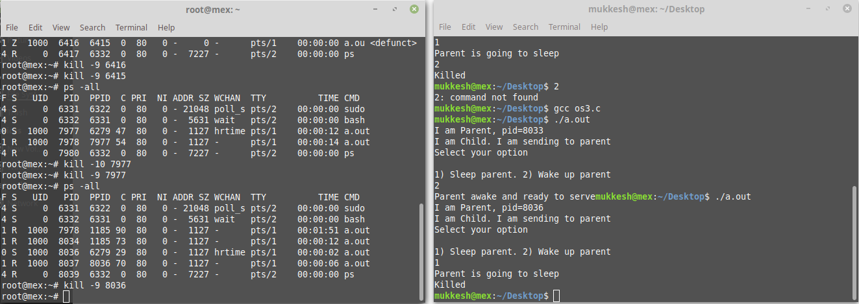

Question 5:

Code:

#include <stdio.h>
#include <sys/types.h>
#include <signal.h>
#include <unistd.h>

static int received = 0;

void readUsual(int sig)
{
if (sig == SIGUSR1)
{
received = 1;
}
if( sig == SIGUSR2)
{
received = 0;
}
}

int main()
{
signal(SIGUSR1,readUsual);
signal(SIGUSR2,readUsual);

pid_t pid2 = fork();
if (pid2 < 0)
printf("Can't create child process\n");
else if (pid2==0)
{ while(1)
{
printf("\nChild is here\nMy Pid is:%d and my PPID is: %d Do you want the parent to sleep(1) or wake up(2)?\n",getpid(),getppid());
int a=0;
scanf("%d",&a);
if(a==1)
{
kill(getppid(),SIGUSR2);
printf("Making parent sleep");
}
else
{
kill(getppid(),SIGUSR1);
printf("Waking parent up");
}
}
}
else
{
while(1)
{
if(received==0)
sleep(1);
else
break;
}
}

return 0;
}

Output:

